

CSC 1310 Syllabus, Fall 2025

Data Structures and Algorithms
  - Department of Computer Science, College of Engineering

Instructor Information


April Crockett
Welcome to Data Structures! I am a Senior Lecturer in the Department of Computer Science and have been teaching full-time in the department since 2018. I typically teach the introductory programming courses. I am looking forward to an awesome semester with you all.
Email: acrockett@tntech.edu
Office: Bruner Hall Room 330

Office Hours:
Wednesdays 2:30pm-4pm
Other days/times - If my door is open or cracked, come in!
By appointment (send email or Teams message)

Eddie Gannod – lead GTA for CSC 1310

Hello all! I recently graduated from Tech and am pursuing a Master’s Degree. I enjoy video games, books, and playing the saxophone. I am passionate about education and helping people to understand new concepts, and I’m excited to work with everyone!
Email: epgannod42@tntech.edu
Office Hours in TA Tutoring Space: Clement Hall 402

Office Hours:
Mondays 2pm-4pm
Tuesdays 11am – 1pm
Thursdays 11am-1pm
Fridays 1pm-1:50pm

Course Logistic Information

CSC 1310-001
Location: Clement Hall, Room 212
Days: Tuesday / Thursday
Time: 1:30pm – 2:45pm

CSC 1310-002
Location: Ashraf Islam Engineering Building (AIEB) 361
Days: Tuesday / Thursday
Time: 9:30am – 10:45am

Lab Class
Your lab is located in Ashraf Islam Engineering Building (AIEB), Room 260.
You are required to attend both lecture class and your lab class. The course master schedule (in ilearn under Content) lists the weeks that you will attend lab, and the first lab class is week of Monday, August 25, 2025.

Below is a list of the six lab sections, times, and days:
CSC 1310-101 Mondays 1:00 - 2:15pm AIEB 260
CSC 1310-102 Wednesdays 1:00 - 2:15pm AIEB 260
CSC 1310-103 Tuesdays 12:00 - 1:15pm AIEB 260
CSC 1310-104 Thursdays 12:00 - 1:15pm AIEB 260
CSC 1310-105 Tuesdays 3:00 - 4:15pm AIEB 260
CSC 1310-106 Thursdays 3:00 - 4:15pm AIEB 260

Course Overview

Course Description & Goal
Abstract data types and fundamental data structures including stacks, queues, and trees; algorithms to search, sort, and manipulate data using such structures; and introduction to runtime analysis. Students complete a series of weekly laboratory exercises for developing proficiency in implementing and utilizing data structures.

Requirements to Take the Course

Course Prerequisites/Corequisites
Students must meet one of the requirements below.
- Minimum Grade of ‘C’ in CSC 1300 Intro to Programming
- Minimum grade of ‘C’ in MATH 1910 Calculus I – may be taken concurrently.

Technology Requirements
- Laptop with internet access. Students should follow the College of Engineering recommended Computer Specifications https://www.tntech.edu/engineering/programs/resources/comp-specs.php
- Follow the “Getting your computer set up for CSC 1310” document to get the required software for the course, which includes a text editor and C++ compiler.

Time Requirements
- This course will require a time commitment of 4 hours of classroom & lab time, plus approximately 7-10 hours of “out-of-class” work for a total of 11-14 hours per week.

Major Teaching Methods
- Lectures with In-Class Practices, Group Work, and Live Coding
- Programming Assignments
- Lab Assignments
- Quizzes

Required Materials & Instructional Platforms

Required Textbook – It’s Free!
This section is using an open education resource online textbook in Runestone Academy. The title is
Problem Solving with Algorithms and Data Structures using C++. You will need to register with Runestone Academy for this textbook. Registration is free.
Register with Runestone Academy using the link below.
- Refer to the provided screen shot below.
- Note that when registering, your username can be anything, but the email needs to be your Tennessee Tech email address.
- Make sure your name matches the name that is in ilearn.
- Enter this text string as your course name: tntech_1310_fall2025
- Here is the registration link: https://runestone.academy/runestone/default/user/register
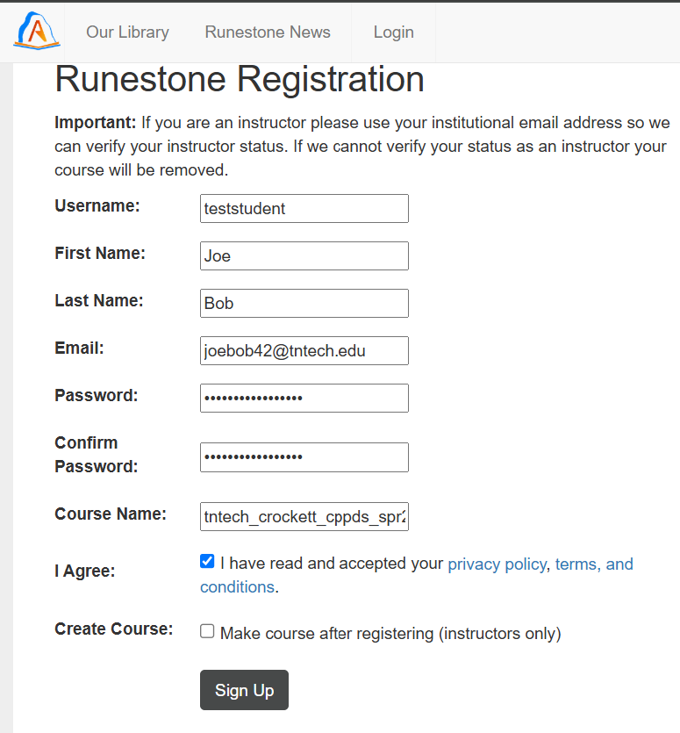
tntech_1310_fall2025

Laptop, Paper, Pencil, & Highlighters
A laptop is required for this class. You must bring your laptop to every lab class.
Part of learning data structures is visualization and many of our in-class practices will require you to draw a representation of a data structure. These are turned in for a participation grade. Sometimes I will bring extra paper, pencils, pens, & highlighters, but sometimes I don’t. You need to be prepared for class every day and make sure you have these materials. I would also recommend a folder or binder to organize all your materials in.

Optional Resources
- https://visualgo.net/en - visualizing data structures and algorithms through animation
- https://www.geeksforgeeks.org/data-structures/?ref=shm
- https://leetcode.com/explore/featured/card/leetcodes-interview-crash-course-data-structures-and-algorithms/

iLearn (TNTECH Learning Management System)
Tennessee Tech’s learning management system, iLearn https://elearn.tntech.edu, is where all announcements, course materials, and sample programs are for this course.
Turn on notifications in iLearn to ensure you do not miss any due dates.
- Set up your Notifications (video): https://www.youtube.com/watch?v=JyVYtIzpoI0
- Set up your Notifications (pdf): https://www.tntech.edu/ilearn/pdf/ilearn-notifications.pdf
- Download the Brightspace Pulse App on your phone for quick access to course materials, schedules, and notifications.
  - Apple App Store: https://apps.apple.com/us/app/brightspace-pulse/id1001688546
  - Google Play: https://play.google.com/store/apps/details?id=com.d2l.brightspace.student.android

Topics to be Covered

- Objects/Classes
- Namespaces
- Templates
- Recursion
- Algorithm Analysis
- Searching Algorithms
- Sorting Algorithms
- Parallel Algorithms
- Lists
- Stacks
- Queues
- Hashing
- Maps
- Trees
- Binary Search Tree
- Graphs
- Balanced Trees / AVL
- Heaps
- Priority Queue
- Coding with AI
- Prompt Engineering

Course Schedule
The detailed course schedule is provided in a separate document named “CSC 1310 Fall 2025 Master Schedule”.

Course Learning Objectives
- Students can apply the tools available for problem solving and algorithm development.
- Students will demonstrate the ability to identify and use the appropriate data structure(s) for a given problem.
- Students will be able to perform testing and debugging of programs.
- Students will be able to develop, design, and document intermediate procedural and object-oriented programs in C++.
- Students will have the ability to perform the runtime analysis of a program.
- Students will be able to read, critique (improve), and verify the correctness of code.
- Students will be able to construct precise and effective prompts for large language models (LLMs) to generate code that correctly implements efficient algorithms to solve computational problems.
- Students will have the ability to implement algorithmic solutions that take advantage of multiple cores via parallel programming
- Students will demonstrate the ability to identify when a problem solution requires interaction with a remote service and be able to develop algorithmic solutions for interacting with a remote service.

Grading & Evaluation Procedures

Grade Distribution
A: 90.0 to 100
B: 80.0 to 89.9
C: 70.0 to 79.9
D: 60.0 to 69.9
F: 59.9 and below

Grade Distribution by Assessment Type

Assessment Type | Percentage of Overall  CSC 1310 Grade
Programming Assignments | 25%
Quizzes | 30%
Lab Assignments | 25%
Homework & Participation | 10%
Final Exam | 10%

- Quizzes – there will be several quizzes during class covering lecture modules. Some quizzes will be over a single module and some I will combine. You will have approximately 20 to 30 minutes (depending on the quiz) during class to take the quiz. They are closed book, closed notes and are on paper. The quizzes will be like your homework for the module. You may have to write code on these quizzes, but never an entire program. When I return your quiz, keep it! You will use these quizzes to study for the final exam at the end of the semester. If you have an accommodation requiring extra time on quizzes, you may schedule your quiz with the AEC at any time on the same day.
- Programming Assignments – there will be four major programs assigned in this class
- Final Exam – there will be a comprehensive final exam during finals week during our designated final exam time (https://www.tntech.edu/records/finalexamschedules.php)
- Lab Assignments – weekly assignments given to you in lab – part of this grade will require a report to be submitted.
- Homework – Runestone Academy textbook homework assignments
- Participation –in-class participation, in-class activities & assignments, filling out surveys at beginning and end of the semester, and watching assigned videos.

Tutoring
There is free tutoring from your lab instructors (TAs) almost every day! The tutoring schedule is available in ilearn under Content and then Tutoring Schedule.
All in-person tutoring is done in Clement Hall, Room 402, which is the CS department’s dedicated tutoring space. On the weekends, tutoring is offered online in MS Teams by contacting via direct message (chat) in Teams the person who is on the schedule. You are required to fill out a super-short form (3 point and click questions) when you get tutored.
If you have any issues with tutoring or if you go to tutoring and no one is there when they are supposed to be schedule, please email Mrs. Crockett (acrockett@tntech.edu).

Course Policies

Grading Policy
- If you have an issue with any grade posted, you must contact me via email within 2 days of the grade being released. If you have notifications set up, you will know all your grades when they are posted.
- All grades will be posted to ilearn.
- Final grades are not rounded up. Example: If you earned an 89.9, then your final grade is a ‘B’.
All emails asking us to add points to your grade at the end of the semester will not be answered.
- Programming assignments will be graded within 1.5-2 weeks of completion.
- All lab and programming assignments will have rubrics that show how you will be graded. Always pay attention to the grade rubric prior to the due date and pay attention to the feedback given with your grade so you don’t repeat mistakes.

Attendance Policy
Attendance is required for both lab and lecture. Make sure to read the late quiz policy below.
Students who are unable to attend class for an extended period due to an emergency/extenuating circumstance (i.e., medical illness, hospitalization, death in the family/bereavement, military or legal obligation), may contact the Office of the Vice President for Student Affairs at studentaffairs@tntech.edu to request an absence notification.

Late Quiz Policy
- You must have a documented (doctor’s note), excused absence to make up a missed quiz.
- You must email Mrs. Crockett within ONE DAY of missing a quiz to be eligible to make up the missed quiz.
- You will know which days there is a quiz because quiz dates are in the master schedule.

Late Assignment Policy
- Lecture and lab programming assignments may be completed/submitted up to 2 days late at a penalty of 10 points off per day late.
- After 2 days late, the assignment may not be submitted, and the grade will be a zero. Emailed submissions are not accepted.

Class Participation
In this course, the instructors hope to foster a climate of mutual respect where we learn and communicate together as a community where diverse perspectives are heard. Our expectations are listed below:
- Every student will participate actively, maturely, and respectfully in course discussions.
- Assume that others have the best intentions.
- Be inclusive – see someone is left out? Pull them in to your discussion!
- Recognize and value the different backgrounds, experiences, abilities, and knowledge each person brings to the class.

Email Policy
You will be expected to have your notifications set up in ilearn to receive an email when an announcement has been posted to your courses. You will be expected to check your Tennessee Tech email account at least once a day.

Policy Concerning What You Can’t Use in Programming Assignments
You may not use code or syntax in your programming assignments that have not been taught in the class without referencing your source. You may not ever use the following in your programs:
- while(true) or while(1)
Check out https://sites.tntech.edu/acrockett/2025/08/15/why-is-whiletrue-or-while1-bad-programming-practice/ to see why this is bad programming practice.
- goto statements
Check out https://sites.tntech.edu/acrockett/2025/08/15/why-is-goto-bad-programming-practice-in-c/ to see why this is bad programming practice.
- recursion including recursively calling main
- exit()
- ternary operators (any syntax requiring a ‘?’)
- lambda functions
If you use any of the things listed above or use code that has not been taught in the class (without referencing your detailed source) then full points will be deducted for that criteria item in the rubric.

Student Academic Misconduct
Maintaining high standards of academic integrity in every class is critical to the reputation of Tennessee Tech, its students, faculty, alumni, and the employers of TTU graduates. Academic integrity is at the foundation of the educational process and key to student success. Students with academic integrity are committed to honesty, ethical behavior, and avoiding academic integrity violations. All students must read and understand Policy 216: Student Academic Integrity. Please see the Academic Integrity website (https://www.tntech.edu/provost/academicintegrity/) for more information. The CS department considers cheating to be a very serious offense, and this conduct will result in a zero on the assignment as well as a submission for academic misconduct for all involved parties. Here is a list of activities that are considered cheating (Academic Misconduct) in CSC 1310 for individual assignments:
- Showing another CSC 1310 student more than one to two lines of your code is cheating. This includes emailing (or otherwise sending) your code to someone or looking at code that was emailed (or otherwise sent) to you. The only exception is if the other student is your peer programming partner in a lab assignment.
- Having your mom/dad/friend (any person) help you with any part of your lab or programming assignment who is not one of the TAs or an instructor and not providing a comment saying that you got help from that person on a part of your assignment. Note that getting help from outside sources (previous students, library tutors, etc.) is not encouraged as they may not be familiar with the concepts and up-to-date versions of C++ that we are teaching.
- Posting your solution to a public website (like Chegg or https://repl.it/).
- Using generative artificial intelligence (ChatGPT, Copilot, etc) to create or assist in creating your program when it is not allowed. (See the Generative AI Policy below)
- Paying someone to write your code.
- Taking solutions off any website or forum and submitting them as your own work.
You MUST document all code sources if you use any part of code from an external source outside of ZyBooks, course presentation slides, or example programs provided by the instructors. This is an example of what we should see if you an external resource like stackoverflow or cplusplus:
/*
Figured out how to replace part of a string with another string on
stackoverflow and cplusplus.com.

stackoverflow URL: https://stackoverflow.com/questions/3418231/replace-part-of-a-
string-with-another-string
cplusplus URL: https://cplusplus.com/reference/string/string/replace/
*/
a.replace(start_pos, 1, "a panda");
You ARE encouraged to search for solutions to your problems online via resources discussed in class (cplusplus.com, stackoverflow, or geeksforgeeks) but do not copy/paste any code and always reference a source in your program comments if you use it!

Generative AI Policy
In this course, Generative AI resources are allowed to be used for specific assignments, as designated by the instructor. Each assignment where generative AI is allowed, it will be clearly stated in the assignment directions.
To ensure academic integrity, students must openly disclose any AI-generated material they utilize and provide proper attribution. This includes in-text citations, quotations, and references.
To indicate the use of a Generative AI resource, a student should include the following statement in their code as a comment: "The author(s) acknowledge the utilization of [Generative AI Tool Name], a language model developed by [Generative AI Tool Provider], in the preparation of this assignment. The [Generative AI Tool Name] was employed in the following manner(s) within this assignment [e.g., brainstorming, grammatical correction, citation, specific section of the assignment]."
Proper citation guidelines can be found on the CITL website.

Disability Accommodation
Students with a disability requiring accommodations should contact the accessible education center (AEC). An accommodation request (AR) should be completed as soon as possible, preferably by the end of the first week of the course. The AEC is in the Roaden University Center, room 112; phone 931-372-6119. For details, view Tennessee Tech's policy 340 – services for students with disabilities at policy central.

Let Others Get to Know You
One way that you can help build community between students and the instructor in this course is by letting others get to know you. Below are instructions on how you can change your name to your preferred name in iLearn and add your profile photo in iLearn and in your school email.

Change to Your Preferred Name in iLearn!
https://blogs.tntech.edu/techtimes/2022/administration/how-to-preferred-name-change-for-students/#:~:text=Students%20can%20request%20to%20use,Just%20fill%20out%20the%20form.

Add Your Profile Photo to iLearn
- Click on your name in the top-right corner of ilearn once you are logged in.
- Click “Profile”
- Click “Change Picture”

Add Your Profile Photo to Microsoft 365
One helpful thing you can do to let your instructors or potential future employers get to know you is to add a profile picture to your TTU email in outlook. It is easy. Here are directions on how to do it: https://support.office.com/en-us/article/add-your-profile-photo-to-office-365-2eaf93fd-b3f1-43b9-9cdc-bdcd548435b7

Additional Campus Resources

Technical Help
If you are experiencing technical problems, visit the myTech IT Helpdesk for assistance.
If you are having trouble with one of the instructional technologies (i.e. Zoom, Teams, Qualtrics, iLearn Respondus, or any technology listed here) visit the Center for Innovation in Teaching and Learning (CITL) website or call 931-372-3675 for assistance.
For accessibility information and statements for our instructional technologies, visit the CITL's Learner Success Resource page.

Health and Wellness

Counseling Center
The Counseling Center offers brief, short-term, solution-focused therapeutic interventions for Tennessee Tech University students. The staff of the Counseling Center is available to assist students with their personal and social concerns in hopes of helping them achieve satisfying educational and life experiences. To learn more or schedule an appointment, visit the Counseling Center website.

Health Services
Health Services offers high-quality, affordable care that is accessible and promotes the health and wellness of our Tennessee Tech community. Visit the Health Services website to learn more.

Syllabus & Schedule are Tentative
The syllabus and schedule are subject to change.

